**Fast Track Answers**

**First General Exam**

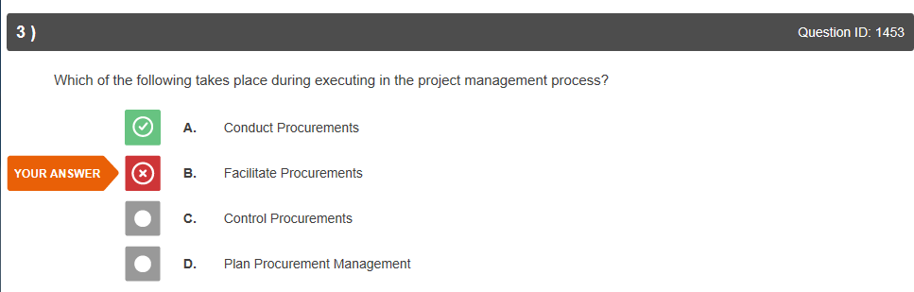

I thought the two were synonymous.

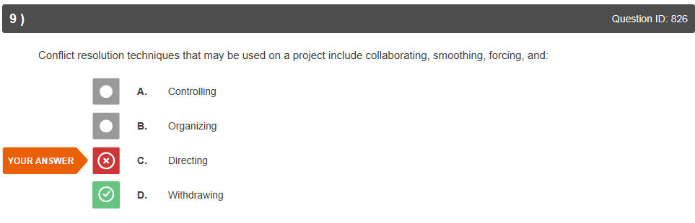

Studied and was better on next test.

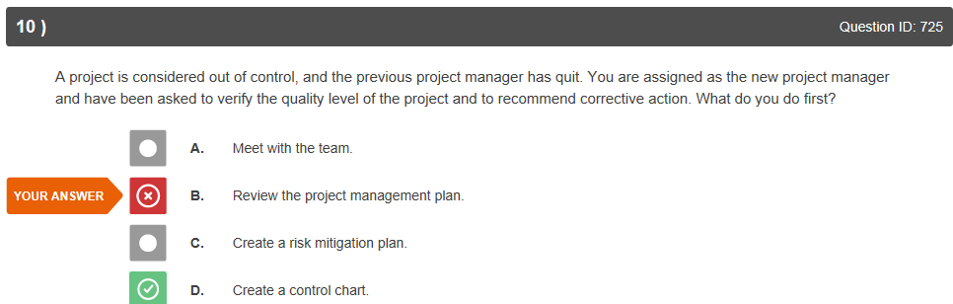

I thought you might want to review the project first.

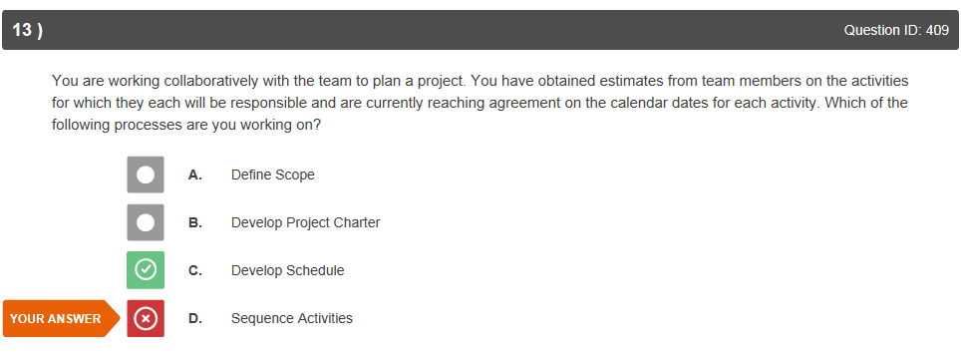

Sequence activities are part of developing schedule, is this because sequence activities is not considered a process?

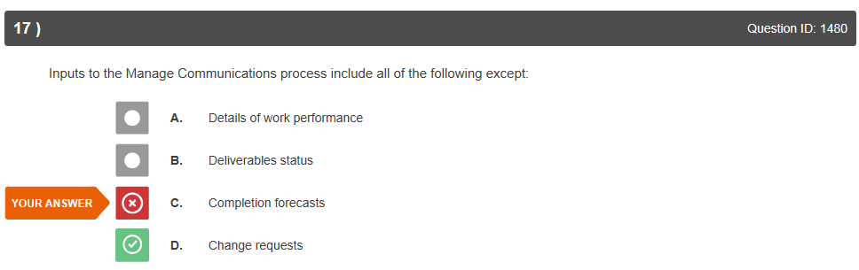

I thought that change requests were integral to every process area and needed to be communicated to the stakeholders at every stage whereas forecasts are part of monitoring and controlling.

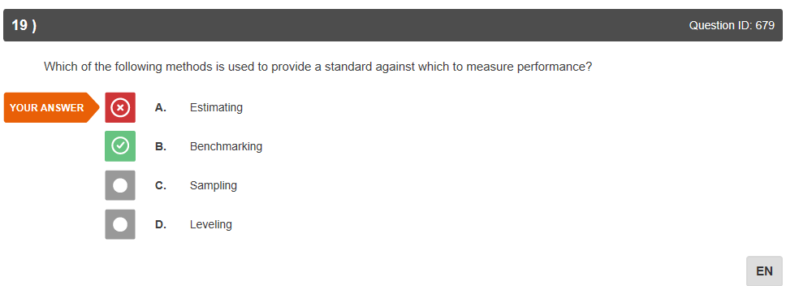

Estimating also assists in measuring performance but benchmarking is considered a standard?

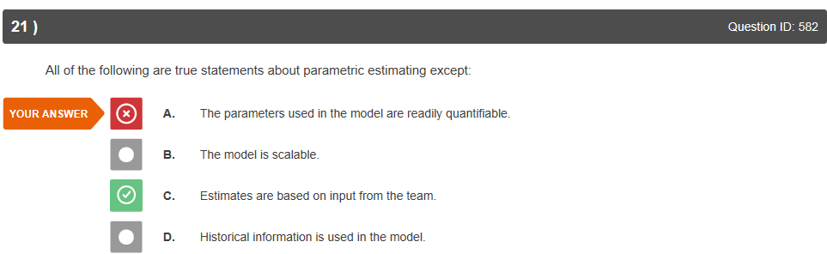

I chose the answer because parametric is more quantifiable than analogous but I see the logic in the answer.

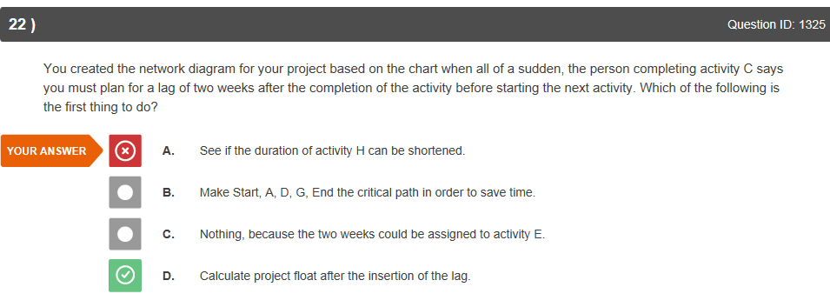

I chose this one because it was the only task with significant time and C as a prerequisite. I see that D is the correct choice.

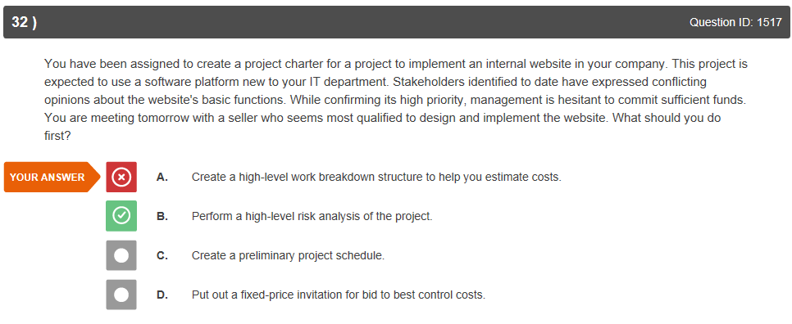

I was distracted by the information about sufficient funds, risk analysis is the best choice.

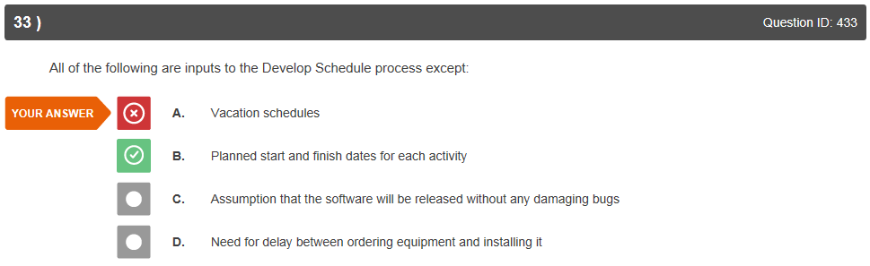

Not sure why activity start and end dates are not input to develop schedule process?

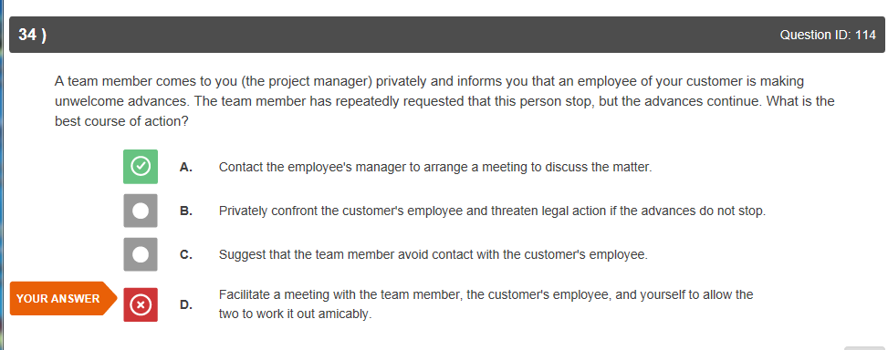

My error.

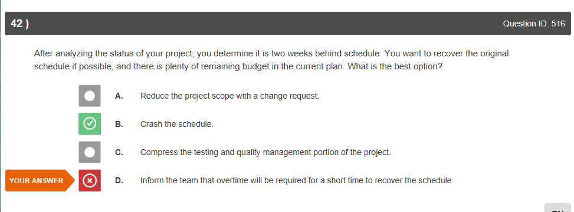

I understood that the answer was more personnel but didn’t consider ‘crashing’ with additional team members.

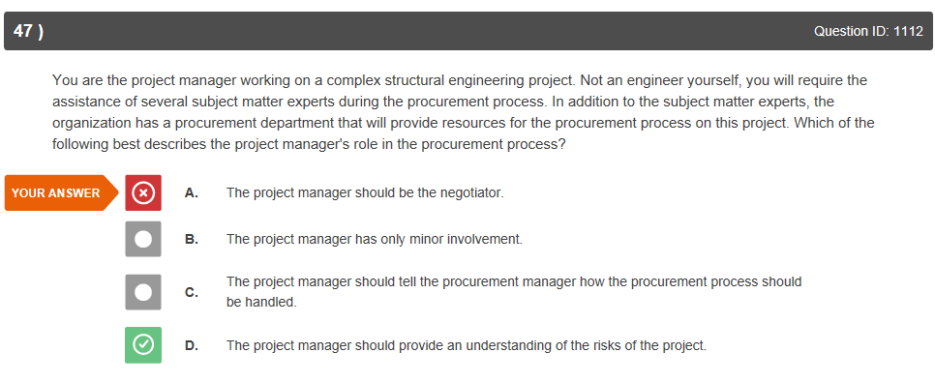

This makes sense.

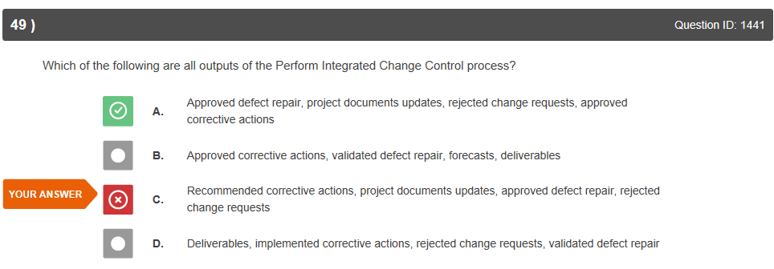

So close ☺

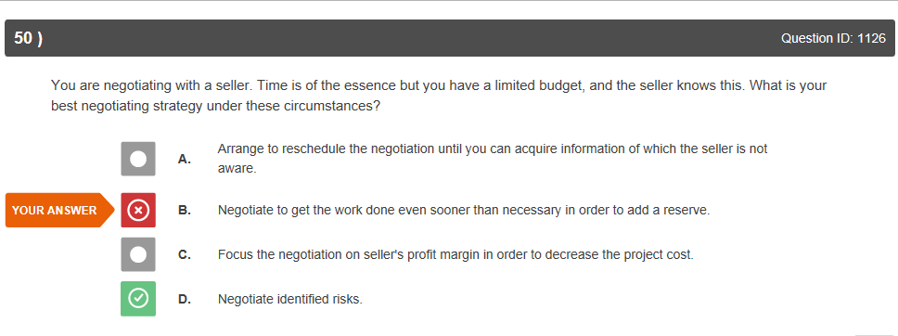

Not sure I understand this one… are you going to allow higher risk for the project for time/$$ considerations?

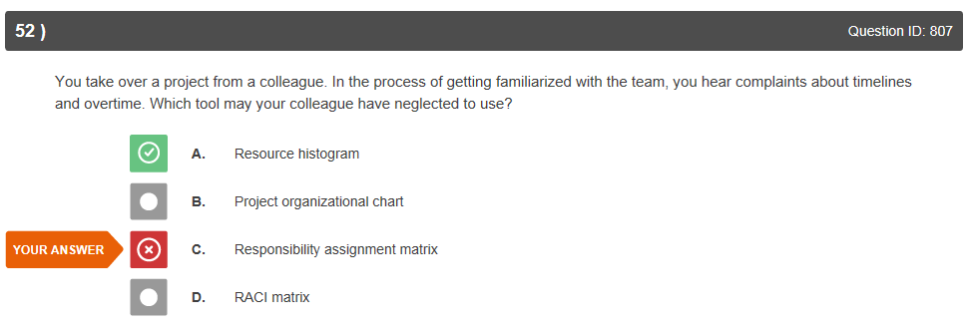

I understand why this was wrong.

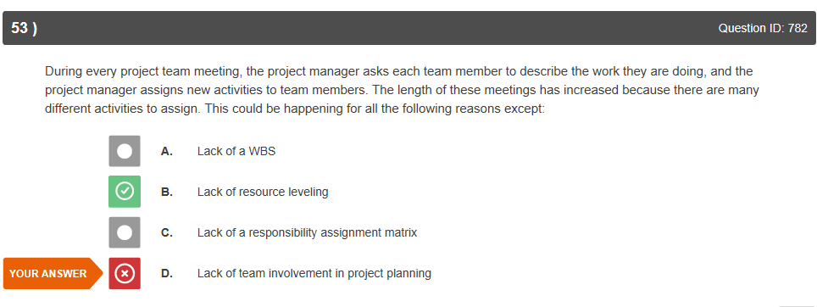

If resource leveling means that the PM will have assigned the work from the WBS at the beginning of the project, then I agree.

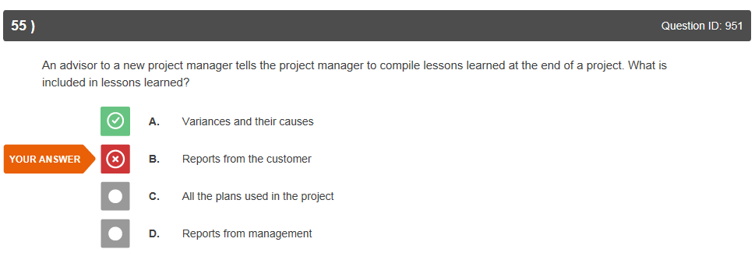

I chose this as there might be lessons to be learned in customer reports (quality issues, service issues, etc.) but I understand the correct answer.

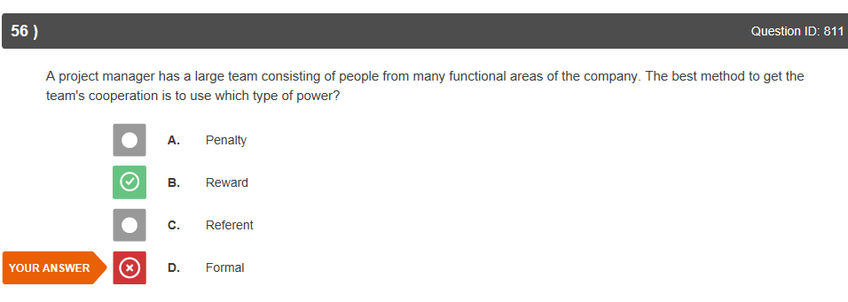

Agreed.

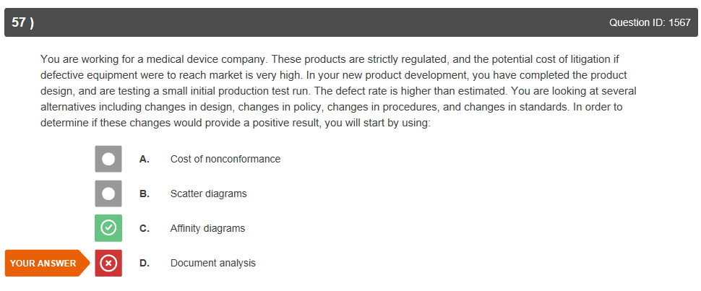

If as a result of brainstorming, I agree.

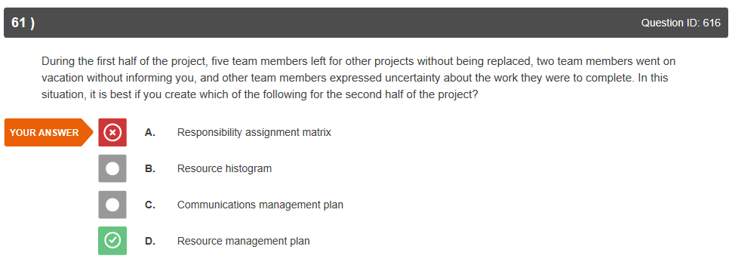

I was assuming that they already had the resource mgmt. plan, the matrix would give them revised detail going forward.

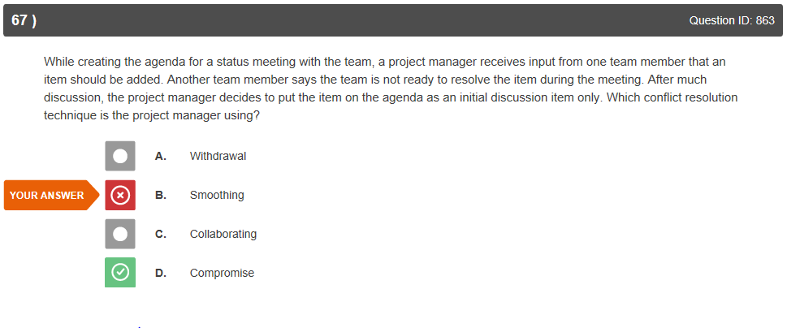

I wasn’t sure that putting it on the agenda wasn’t deciding for the first team member but I see the logic.

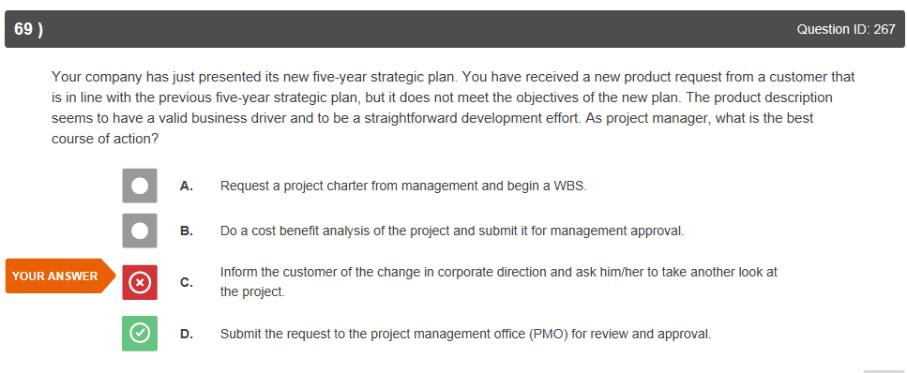

Interesting that even though it does not meet objectives of the company, it is OK to send it to the PMO office anyway.

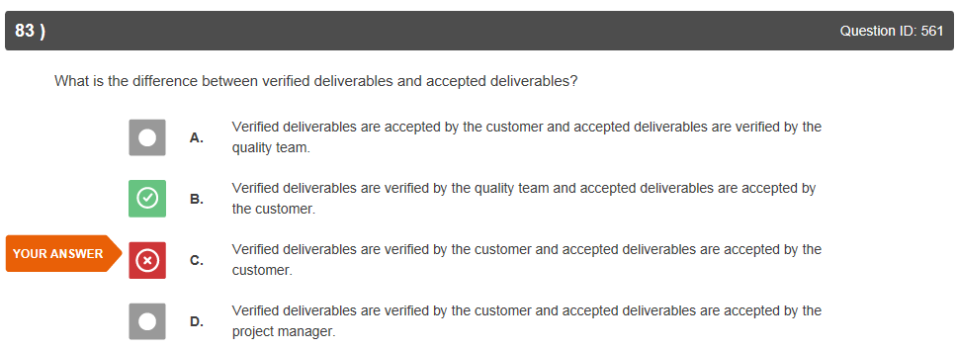

I didn’t know this, great.

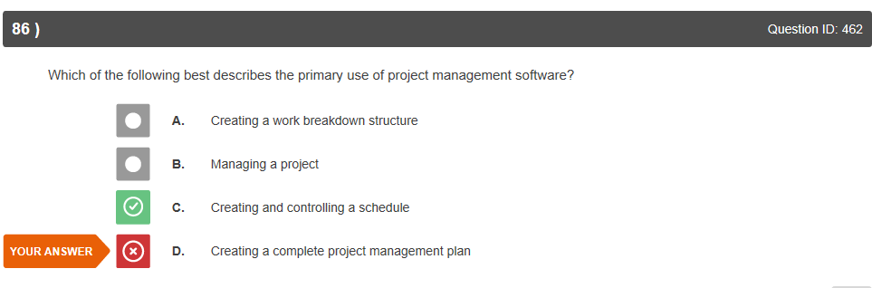

I didn’t know this either, I also thought it was for estimates, costing and risk management.

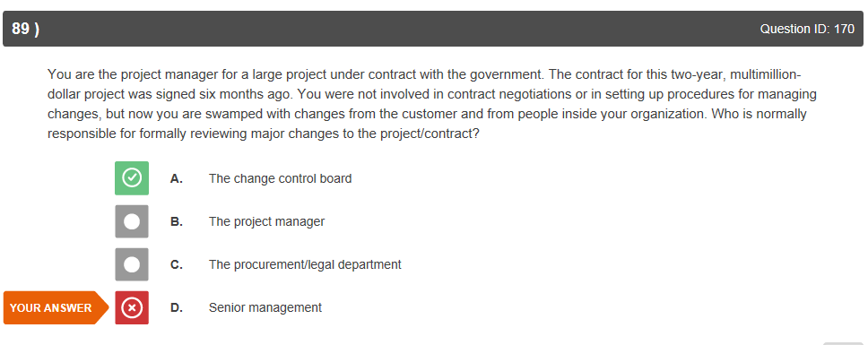

Our change control board had senior management members on it and would make the decisions.

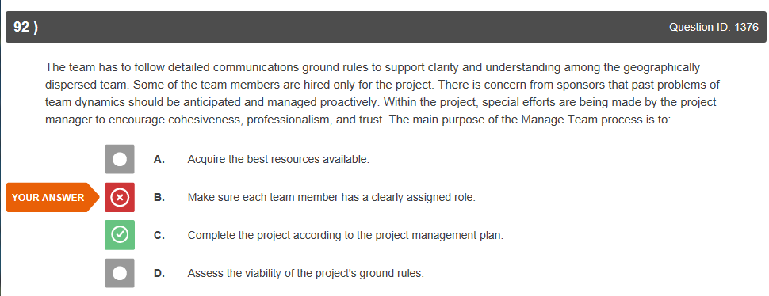

I agree with this answer.

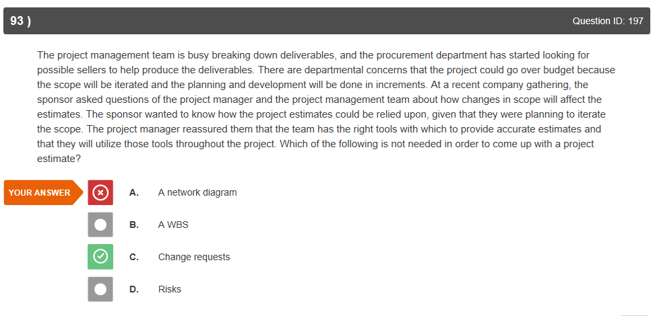

Agreed.

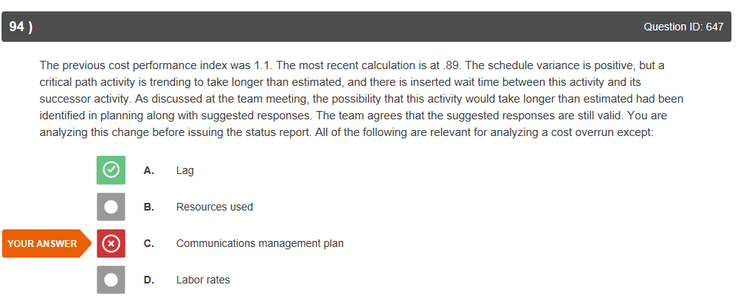

Not sure I understand this one, how the communications management plan can affect cost overrun?

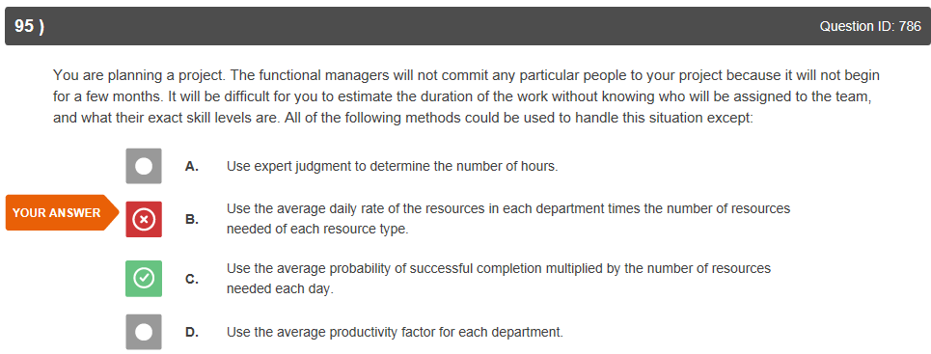

I understand that this is about performance not cost.

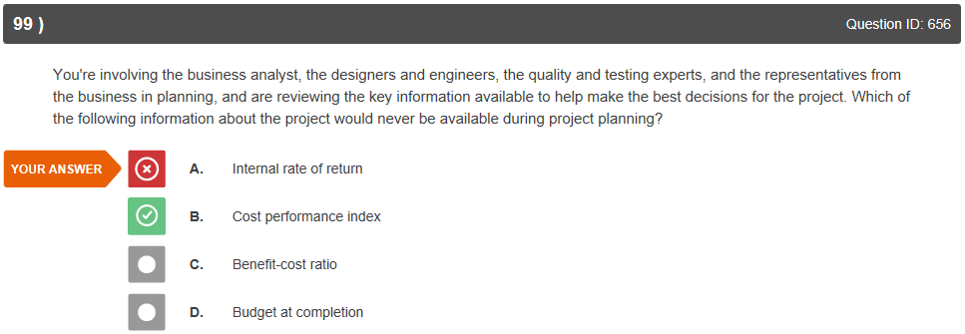

Performance would not be available.

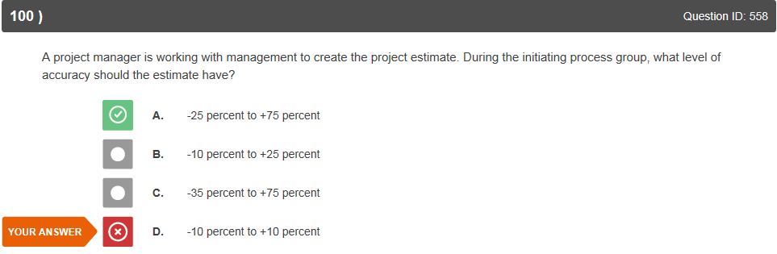

I will need to study estimates more.

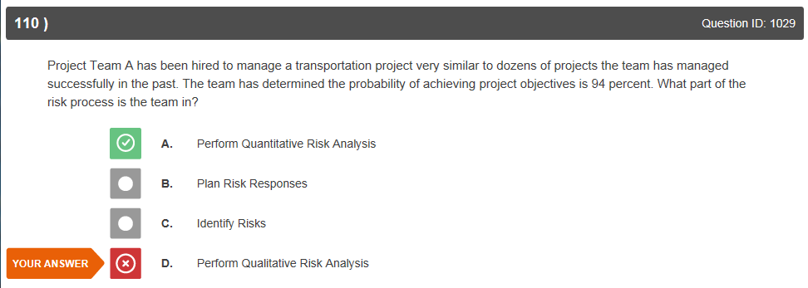

I understand that the qualitative risk mgmt. should be represented by a probability matrix not percentages.

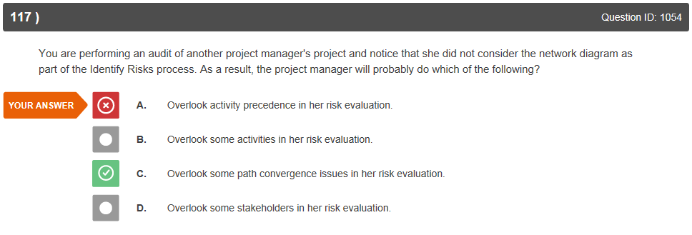

Not sure what path convergence issues would be and why that would increase risk.

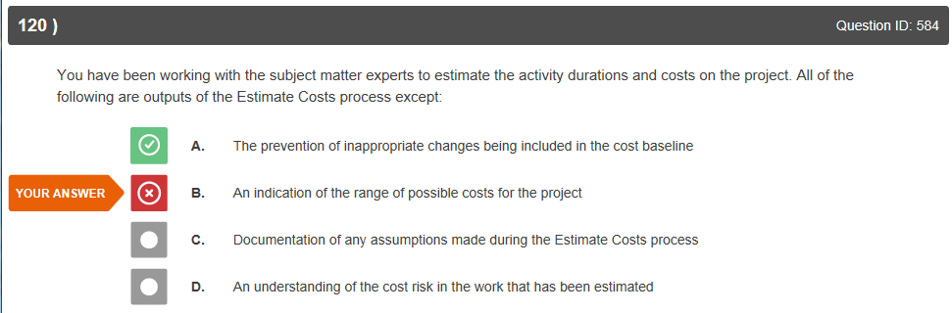

This makes sense.

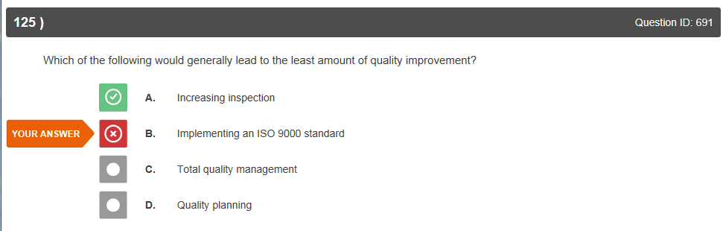

I understand, ‘build in’ not ‘inspect in’ quality.

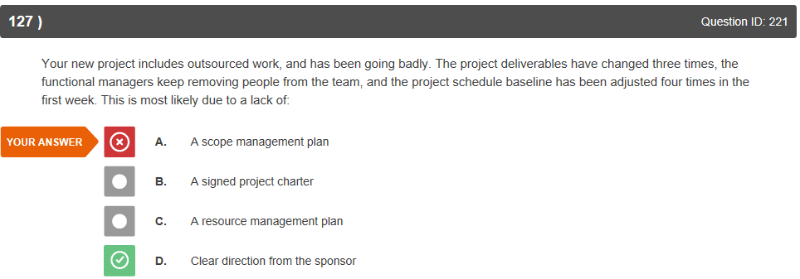

I can’t see this one clearly, this could be caused by unclear scope which a management plan would expose.

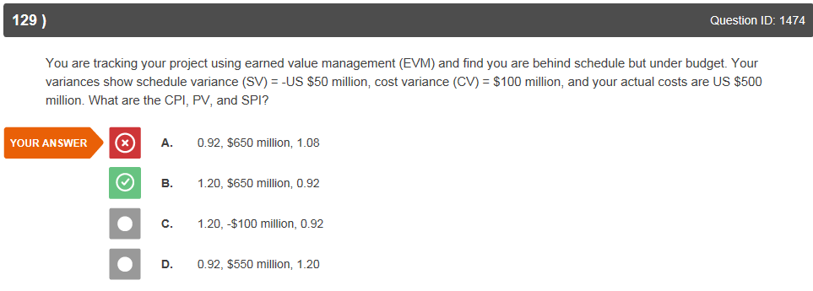

Would need to recalculate.

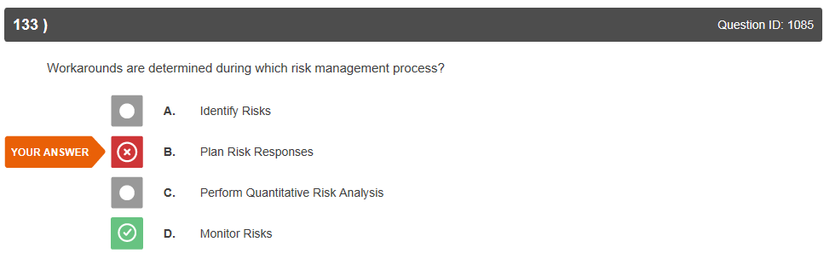

Workarounds are a risk response but is this wrong because it is not a process?

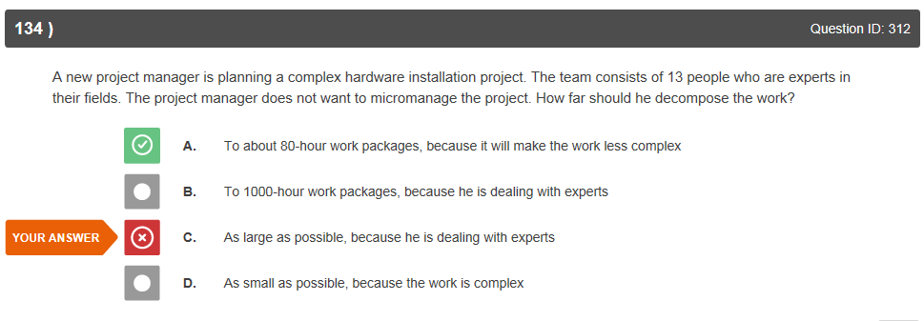

This makes sense.

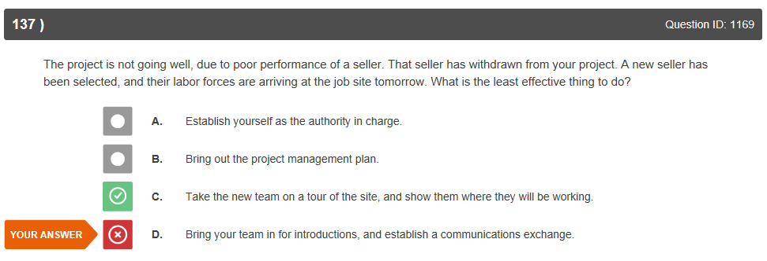

Understand.

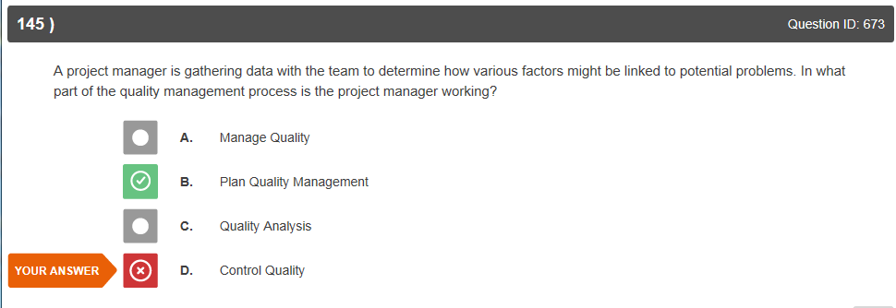

I can see this as correct.

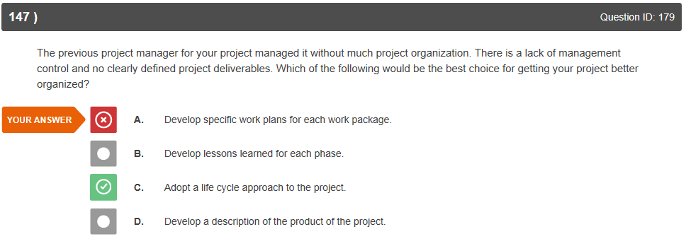

Not sure about what I would have chosen again.

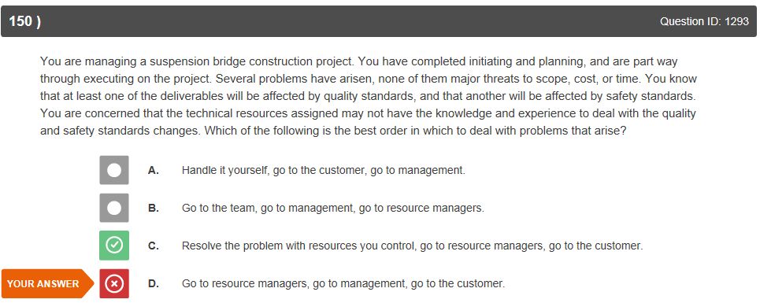

Got it.

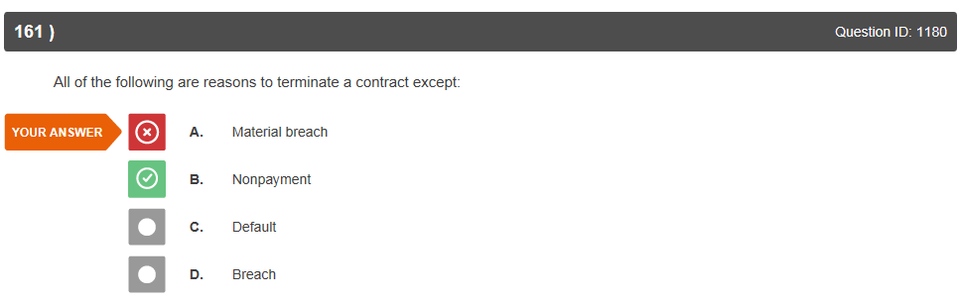

Nonpayment because we are the buyer?

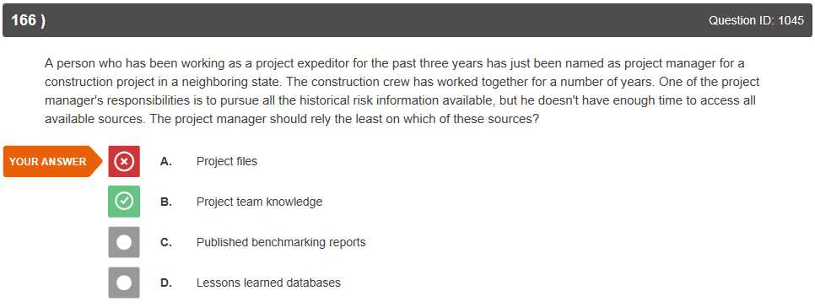

Hmm, rely the least on the expertise of your team over files (especially if he is not able to see them all)? Please explain.

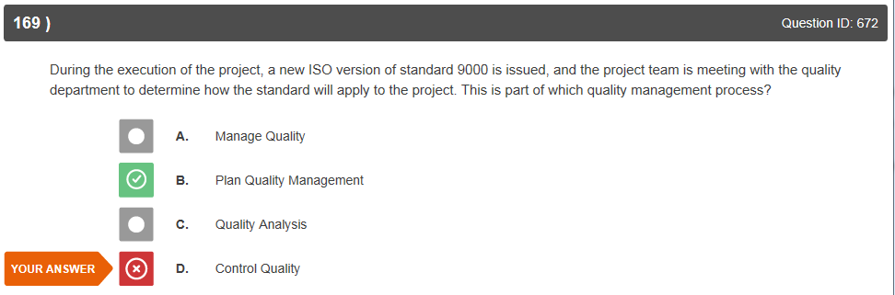

We are past the planning stage and into execution, aren’t we now in the monitoring and controlling phase?

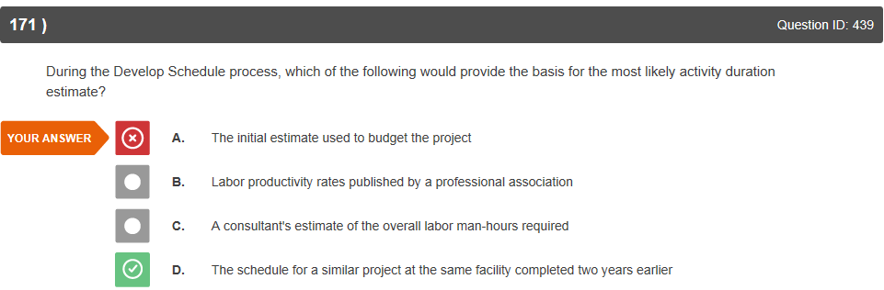

This one is clear.

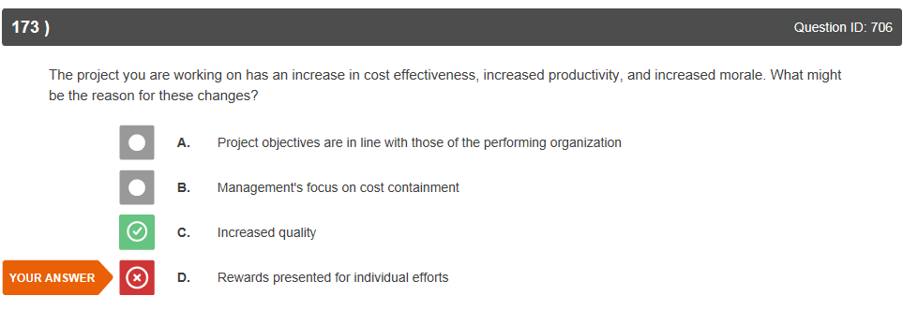

OK.

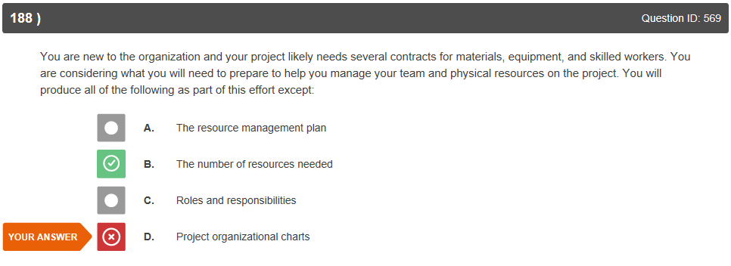

OK.

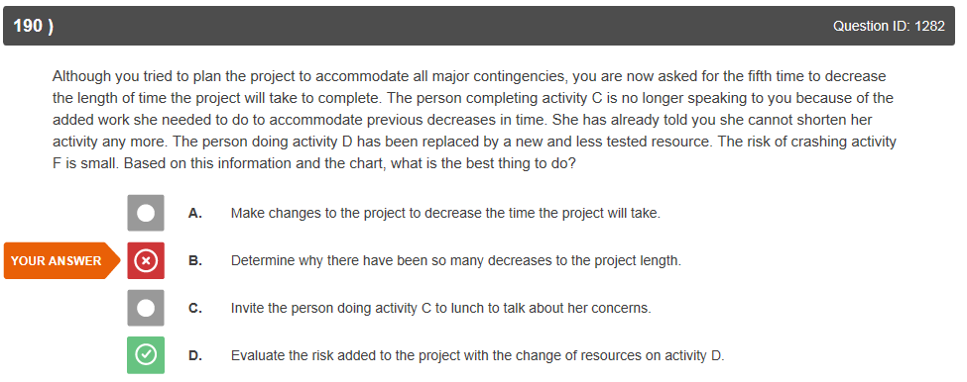

This makes sense.

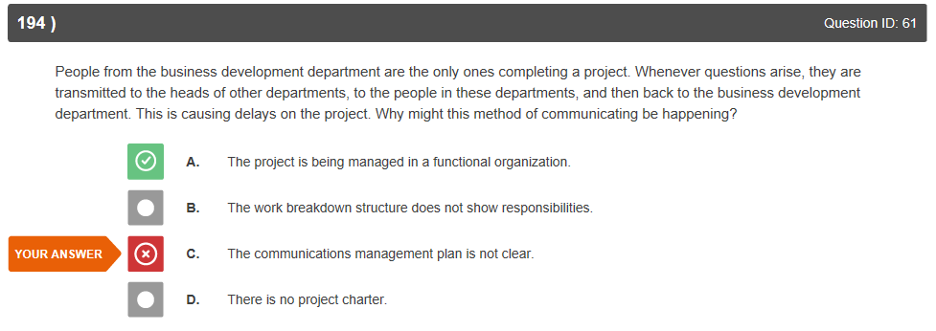

Even a functional organization should know better but OK.

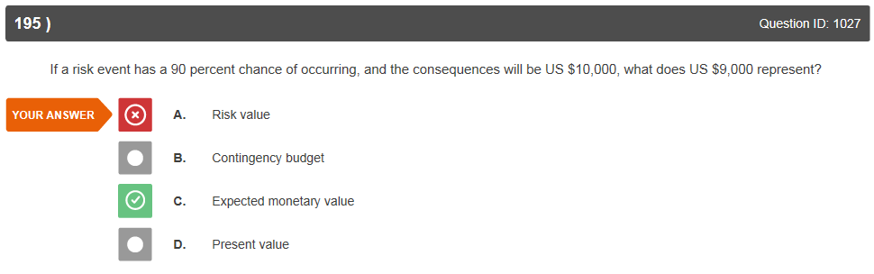

Got it.

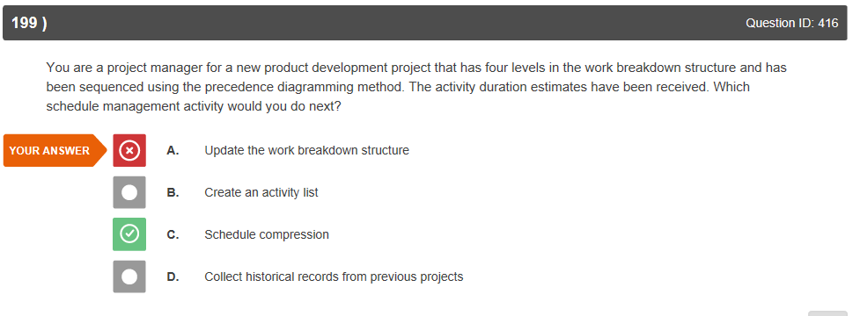

Isn’t schedule compression used when there is a schedule issue that needs special consideration (crashing, fast-tracking)? Why would that be done for a new project?

**Second General Exam**

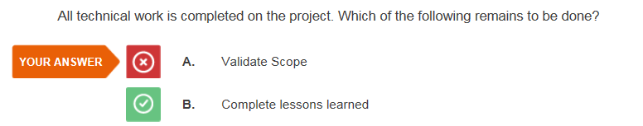

ID #949

I thought that after you completed the work you would need to receive final validation and acceptance.

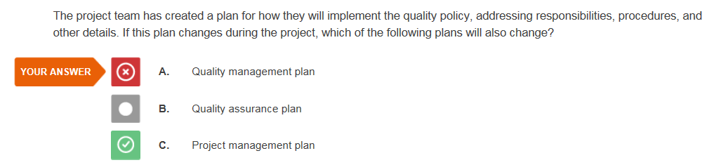

ID #716

I did not fully read the question when it said ‘which of the following plans will ALSO change’.

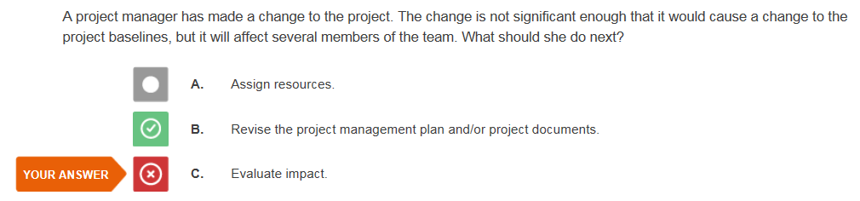

ID #252

This was an error on my part.

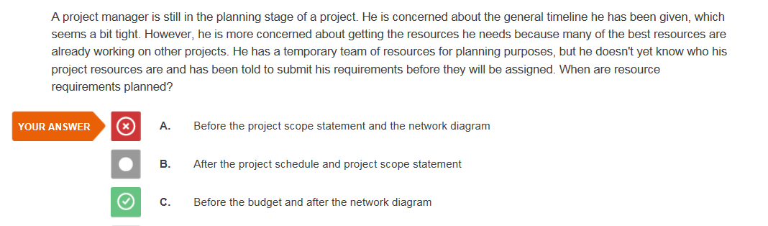

ID #563

I thought that ‘Define and prioritize requirements’ meant resource requirements.

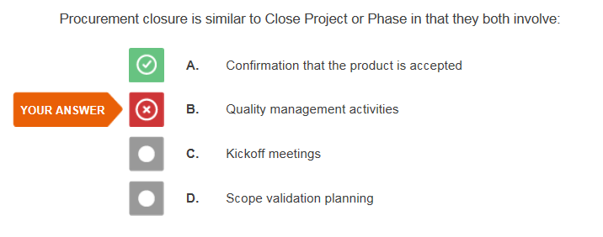

ID #1216

I would probably still get this one incorrect (I understand why but it’s tricky).

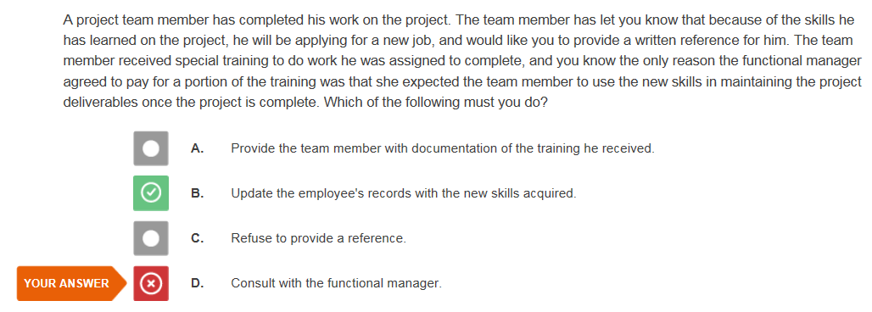

ID #882

I feel that it would be appropriate to notify the functional manager, however, you must update the records, agreed.

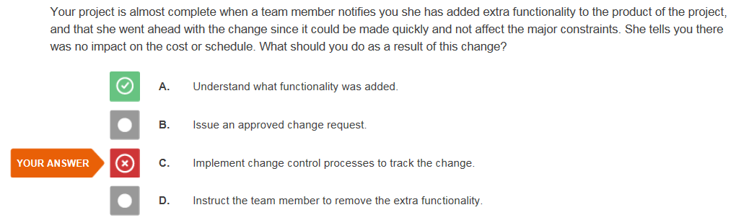

ID #227

I’m not sure I would have chosen this one even now.

ID #227

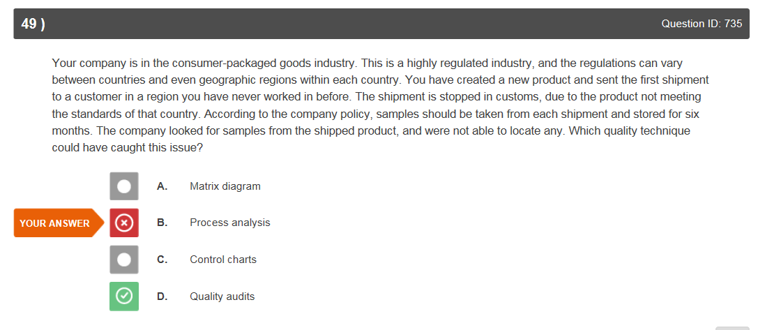

ID #735

I see why this is quality however I also felt that the procedure should have been known and documented.

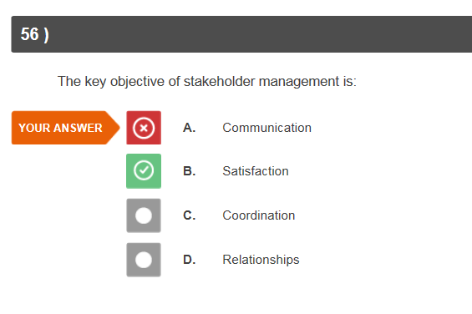

ID #1585

I understand this one.

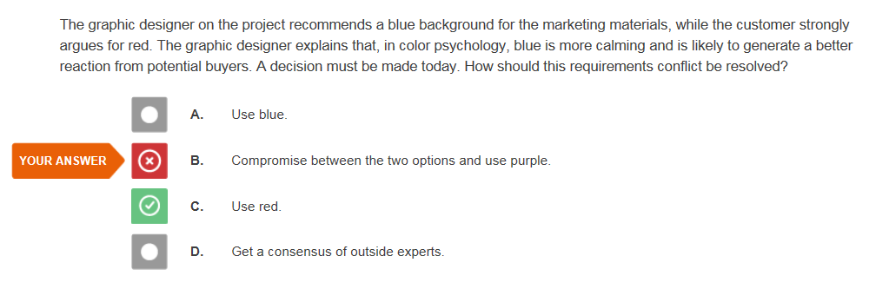

ID #1602

Is the customer is always right? I thought this might be an opportunity to use negotiating skills and leadership to end up in a compromise if the customer would agree to it.

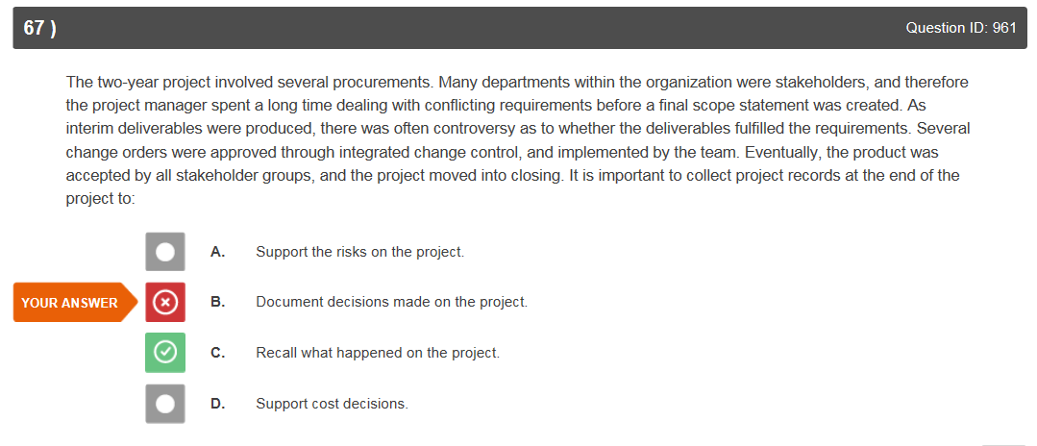

I still might answer this one the same way, as I feel the documented decisions are a more formal way to recall what happened on the project and provide support for the decisions made.

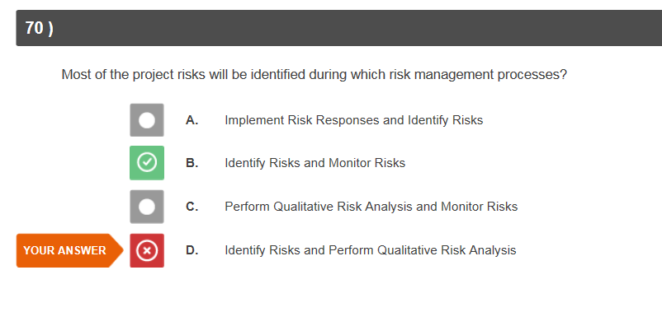

ID #1243

This one was close but I can see why this answer was chosen.

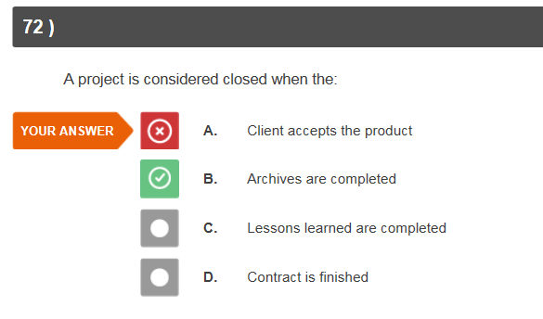.  
I might get the archives and lessons learned confused. I answered this way initially because I remember reading or someone saying that the project was closed when the final product is accepted.

ID #963

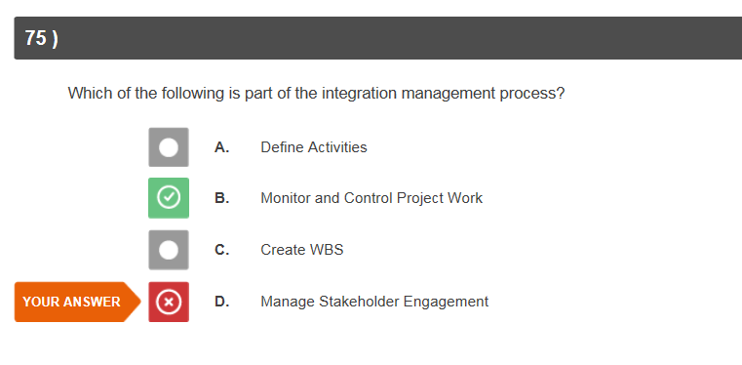

ID #1442

I need to become more familiar with the integration management process (one of my study focuses).

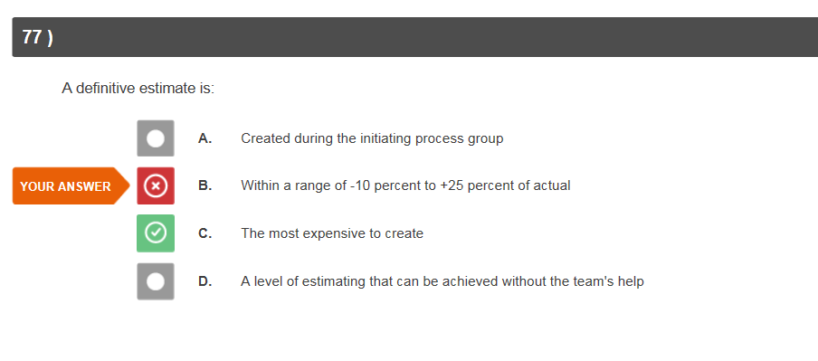

ID #601

I understood the concept that definitive was + to - , just got the numbers wrong (-5 to +10).

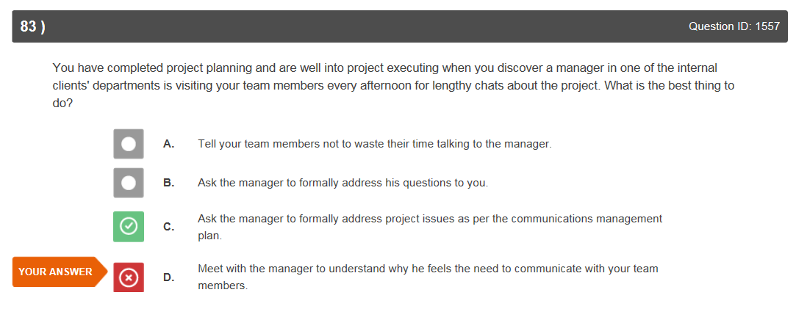

I still might answer this in the same way; the other answer seems a bit formal for the initial discussion (doesn’t foster good project relations). If you verbally told them and they continued, then a formal solution would be appropriate.

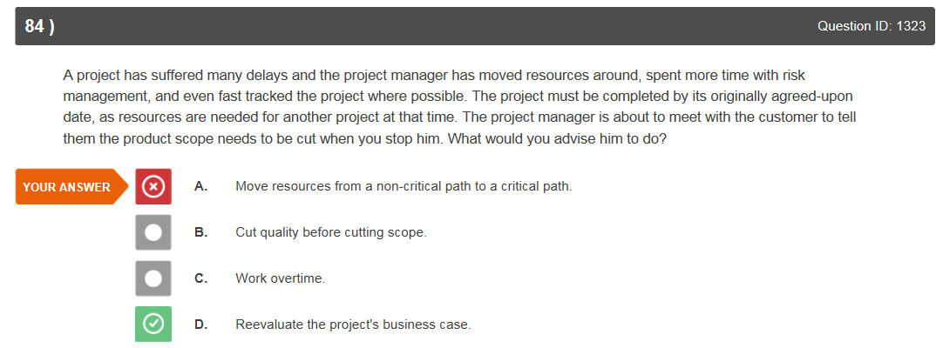

I’m not sure how the business case would help him except that he might be able to cut scope, which is what he was already planning to do. Would this give him another alternative?

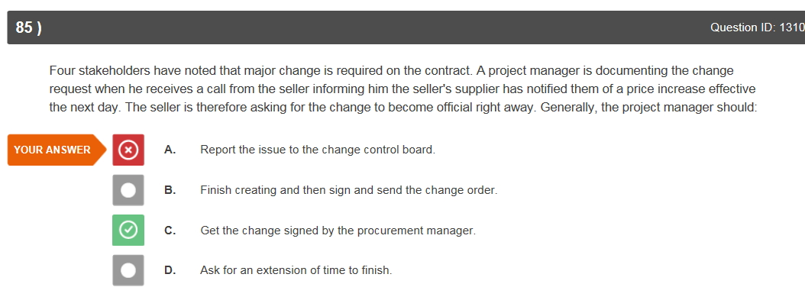

I can see that this is the correct answer.

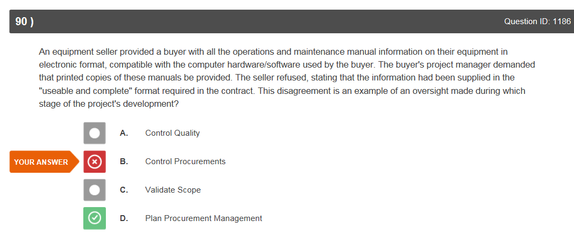

This should have been handled in the finalize procurement documents, in the Plan Procurement Management phase.

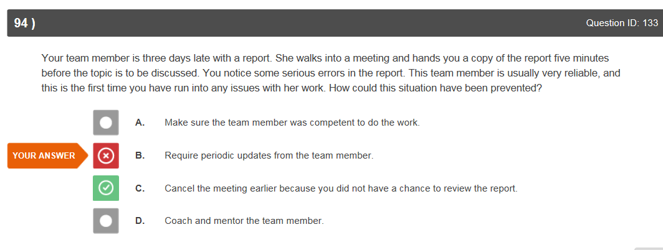

Requiring periodic updates would have also prevented the situation, at least periodic updates (daily) on the late report; when it was obvious it wasn’t going to be completed on time, then the meeting could have been cancelled.

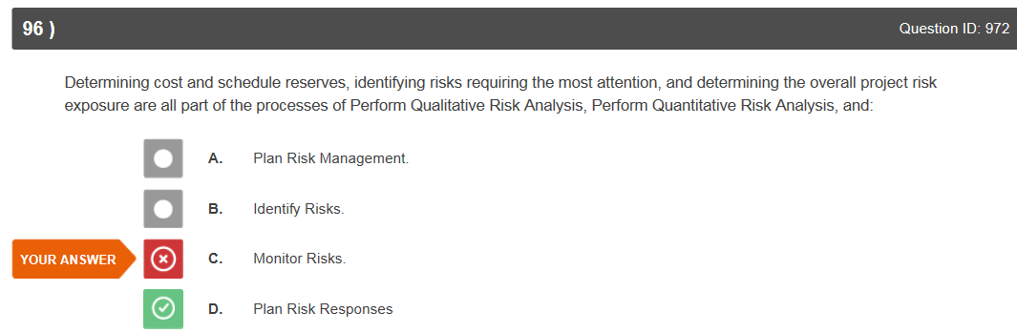

I agree with the correct answer.

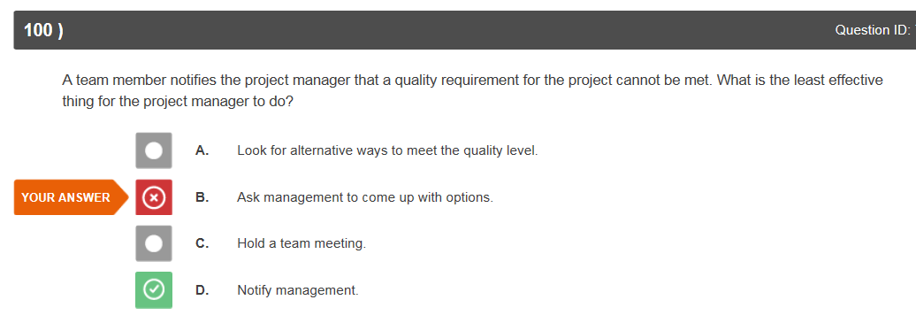

ID #748

This is accepting the failure and not looking hard enough for a solution.

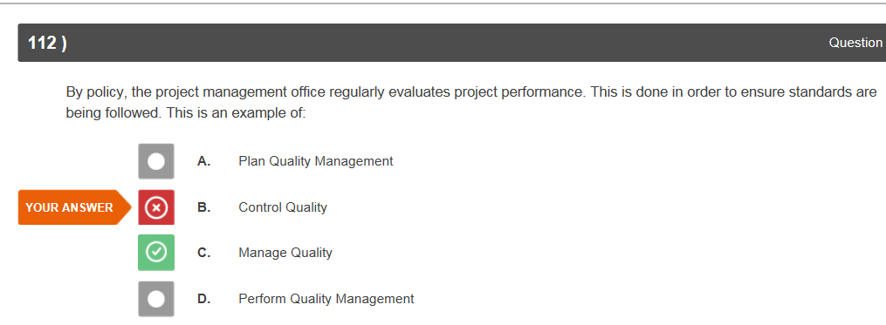

ID #724

Need to distinguish between Manage and Control Quality.

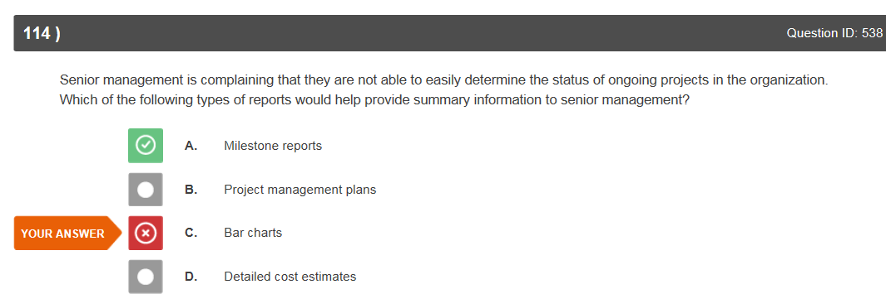

Bar charts could show the progress of each project in comparison to the other projects, milestone reports will only tell what each individual project has accomplished. I might ask senior management what information they are looking for.

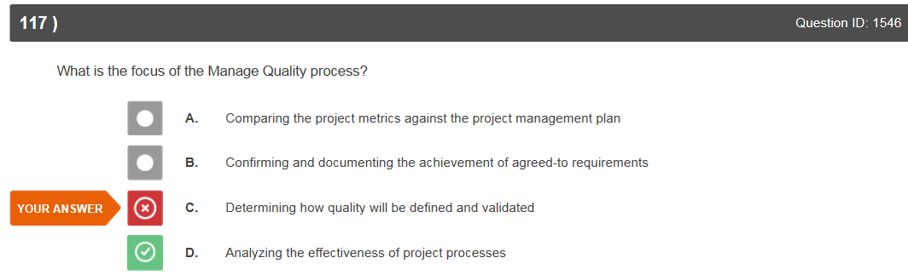

I might have gotten this one correct if it said ‘Quality plan and process are correct and effective’ (as on the process chart) but ‘project processes’ could mean many things in many different knowledge areas.

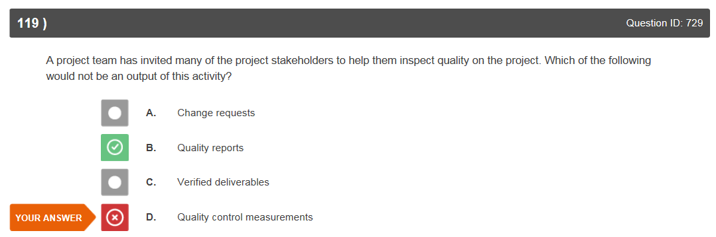

Quality reports are mainly done by the PM but do some stakeholders submit quality reports for their area of expertise?

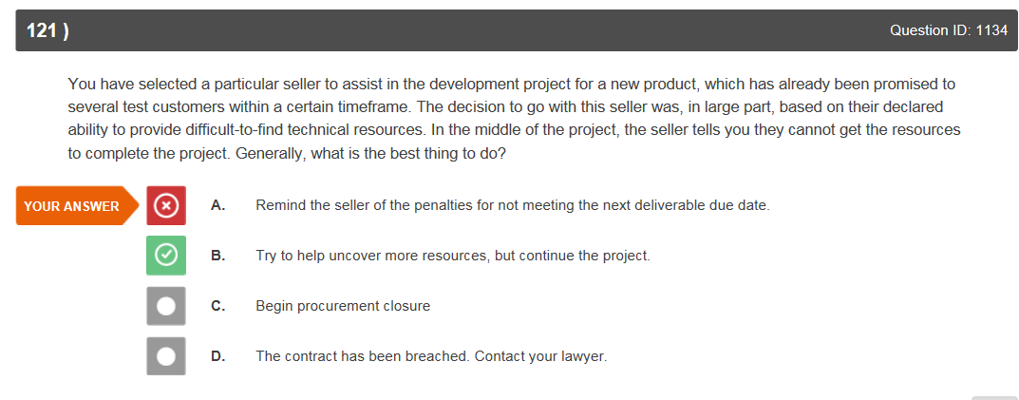

This one is very subjective, the book says that if the seller cannot provide what was promised in the contract that procurement should be closed.

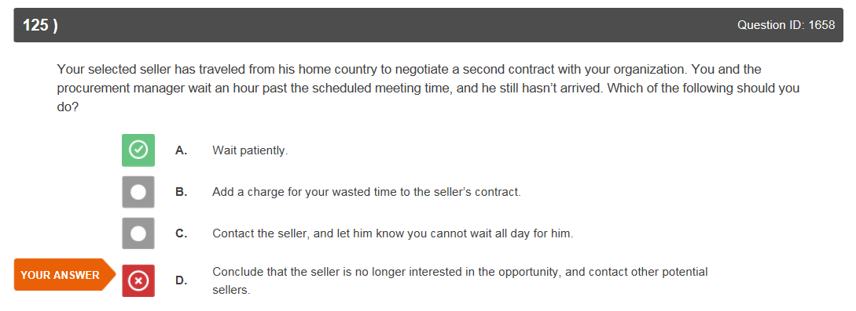

This is very magnanimous, how long should you wait without contact before contacting others?

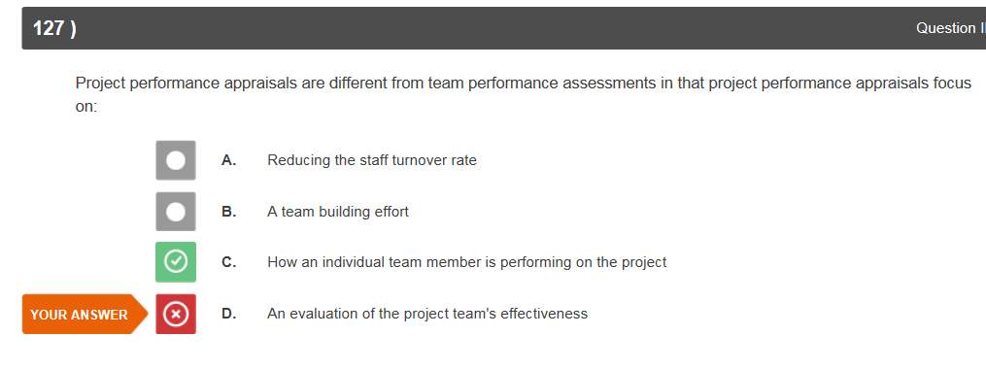

ID #1354

This seems counter-intuitive but OK.

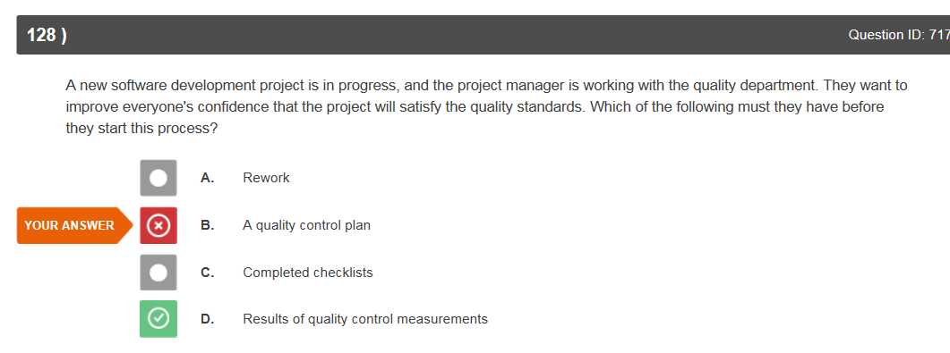

ID #717

This is correct.

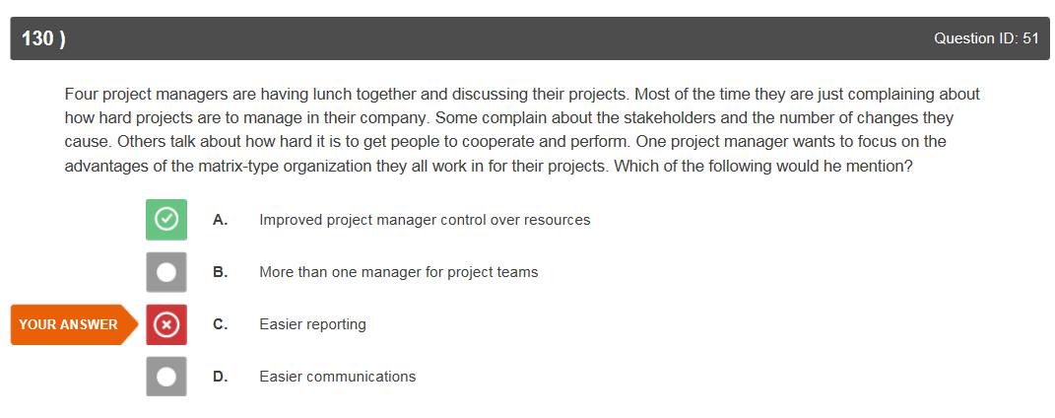

This makes sense.

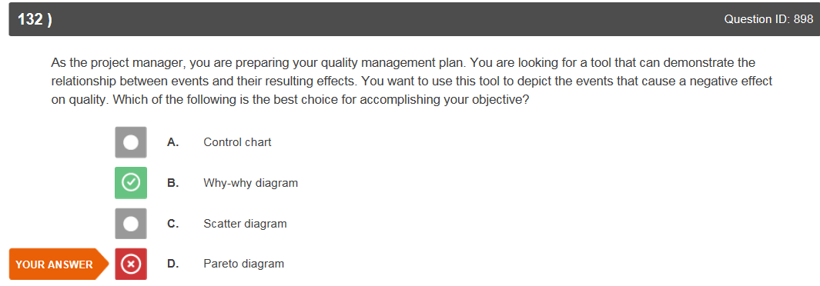

I didn’t realize that the Why-why was also the Ishikawa cause and effect diagram, this is correct.

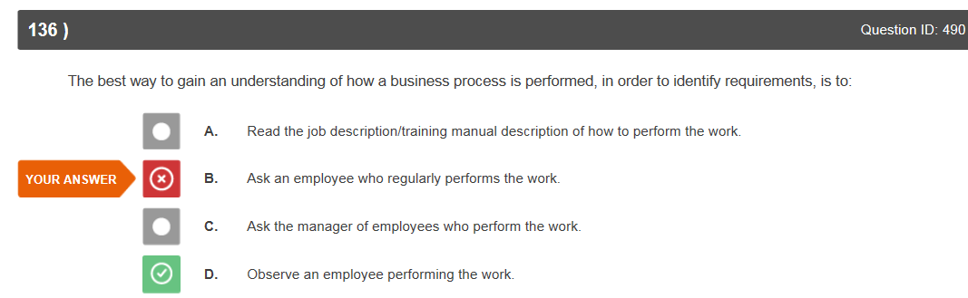

Observing and asking would be best but observing is better than just asking.

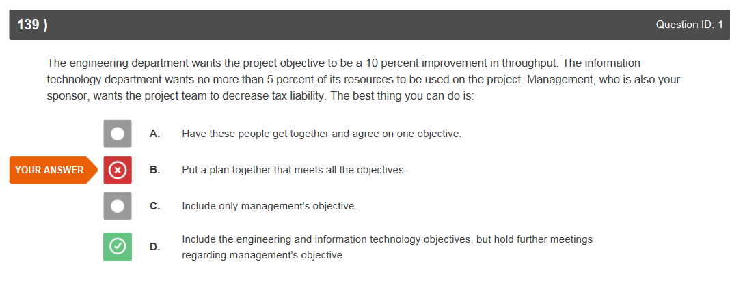

This doesn’t make sense as the sponsor is one of the most influential of stakeholders. Not sure why you would delay their objective.

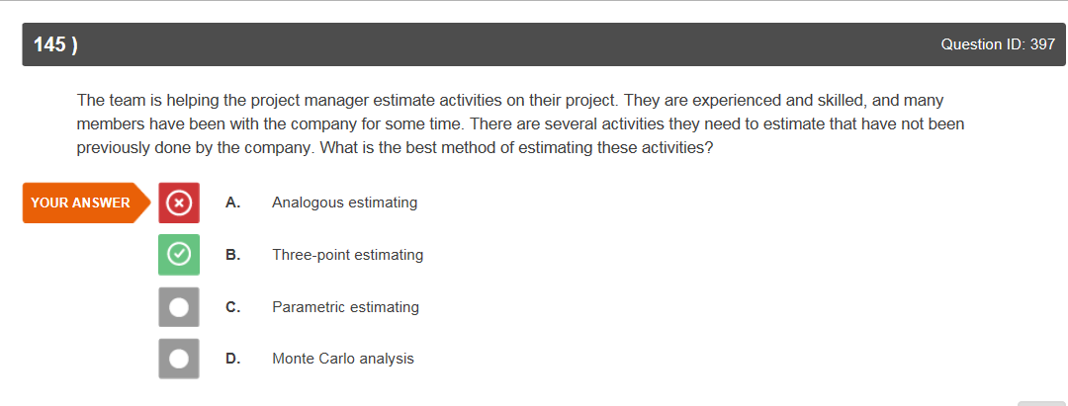

Knew it was A or B as they are both based upon experiential knowledge, I will be studying different methods of estimating.

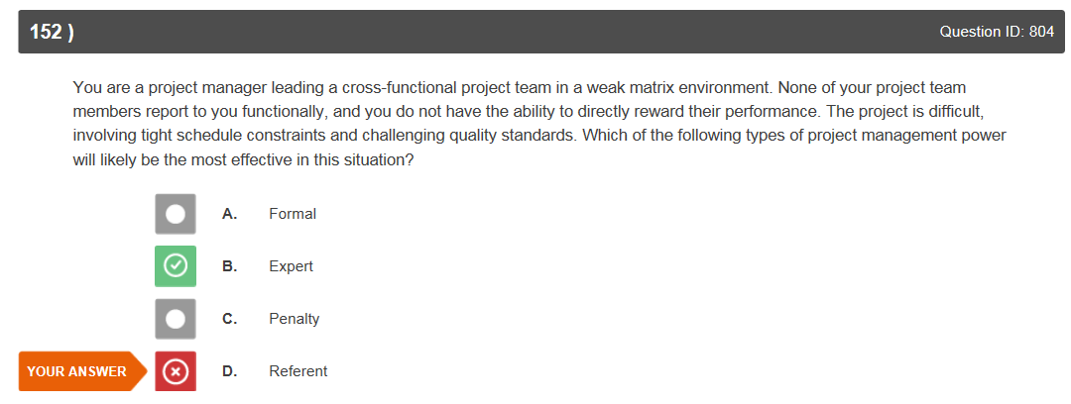.

The PM does not have enough power for Formal, Penalty is rarely motivating in a positive way so Referent or Expert is left. I chose Referent because the question didn’t mention that the PM had any expert knowledge,

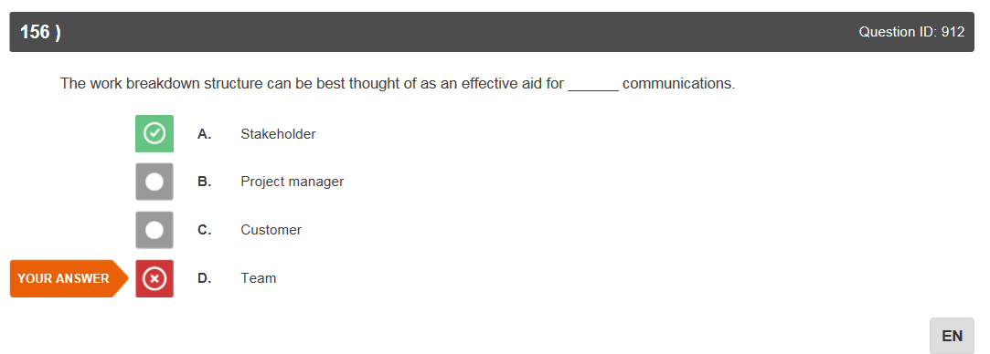

I can see how that would be useful but the WBS is the list of tasks that the team needs to do; all team members should know what other team members are working on as well.

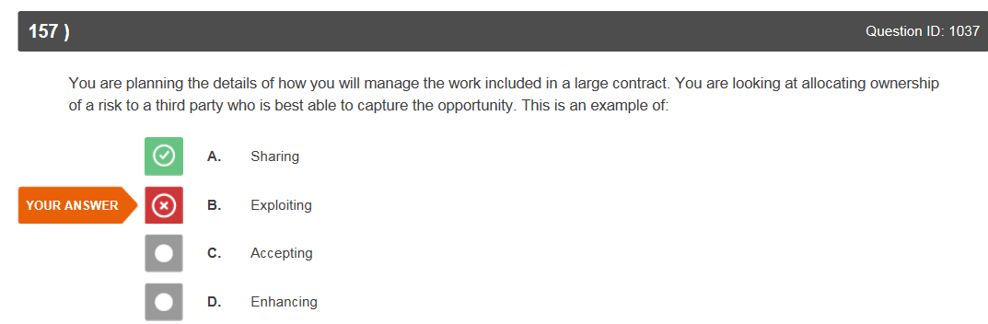

If they own the risk, this is technically not ‘sharing’; they would accept all the risk. Also, “best able to **capture the opportunity”** sounds like there is opportunity to be exploited, with this answer, there is no opportunity, only risk.

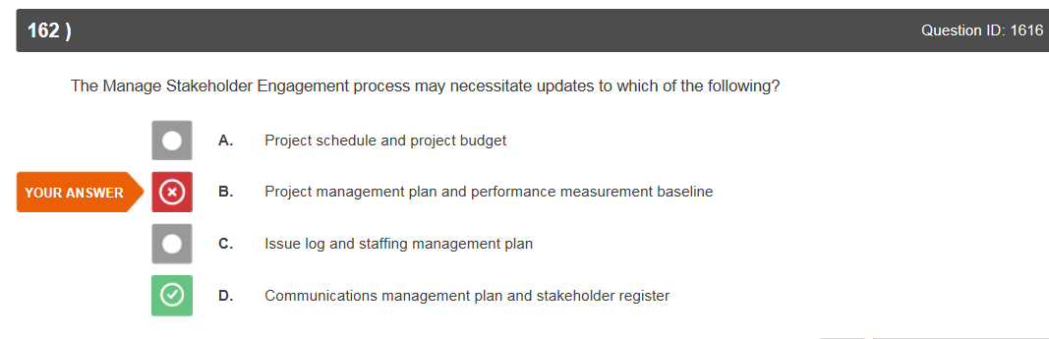

I cannot see why I did not pick the correct answer.

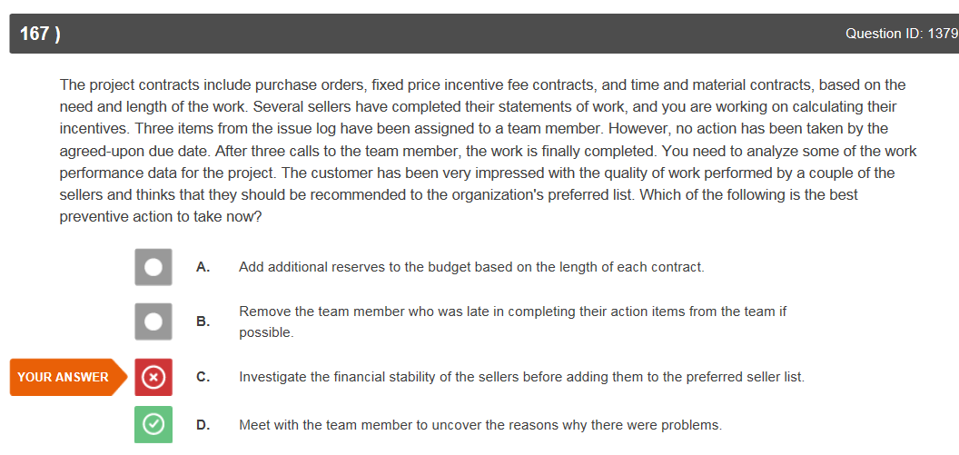

Both C and D need to be accomplished. The customer was satisfied with the work performed so I wouldn’t have thought that D would have taken precedence with the exception of needing to complete the performance report.

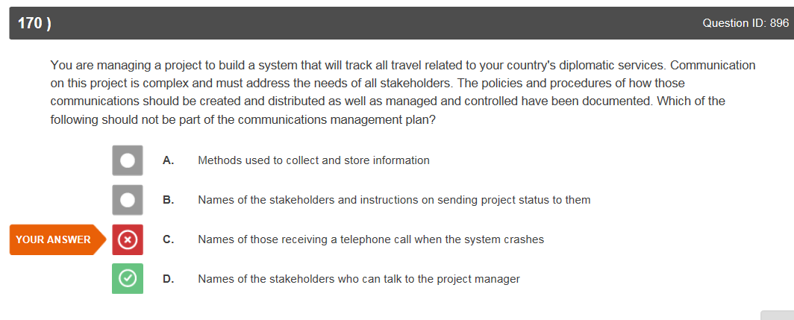Who is permitted to speak with the Project Manager is always part of the communications management plan I thought.

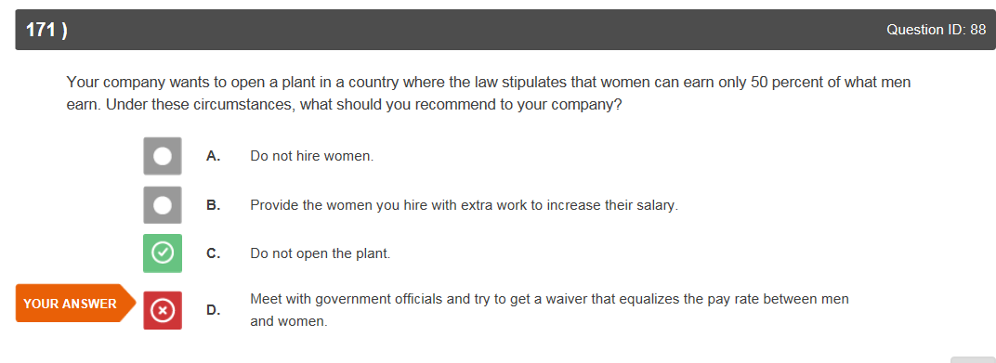

Is there a reason why this is not an idea to try? We are supposed to be creative problem-solvers and this would handle the inequality issue.

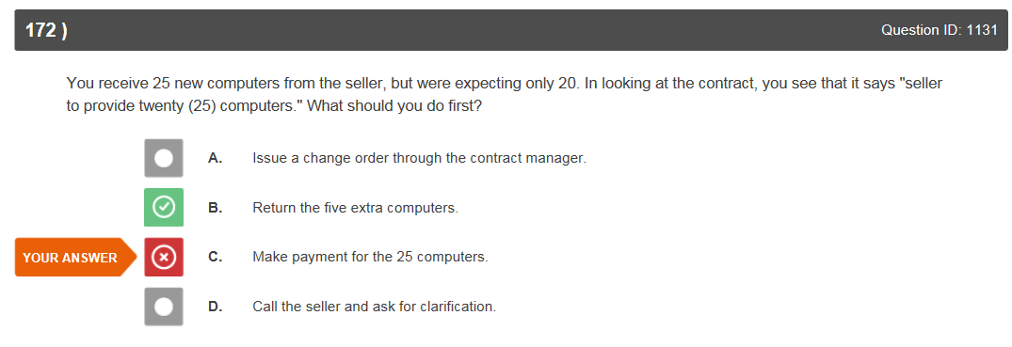

Is this answer saying that the PM would not be obligated to pay for the extra 5 computers or is he just seeing if the seller will accept them back?

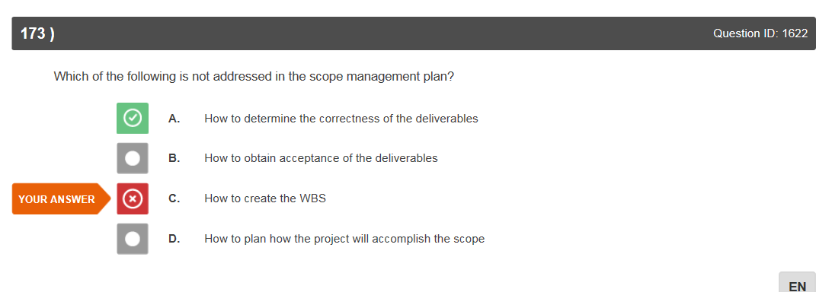

Is the correctness of the deliverables not part of the plan but the process?

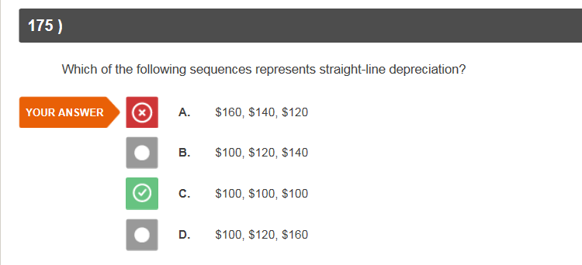

ID #603

This one should not have been missed.

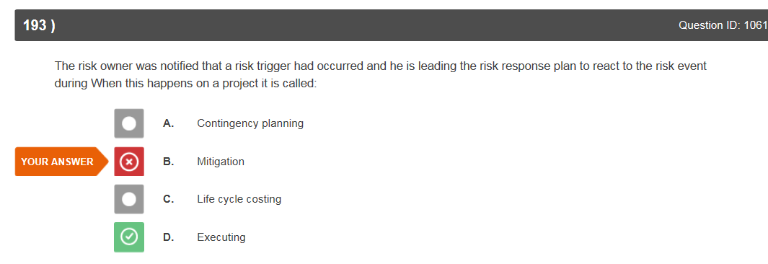

Is this just ‘executing’ and not ‘mitigating’ because we don’t know what type of response plan this is or what the response is designed to do?